Dear Applicant,
we are grateful for your interest to the
SmaLog project.

This Call for staff will be opened
from the 1st of March of 2019 to 15^{s} of March of 2019.

Please note that you are submitting Application for the internship according to the Specail Mobility Strend of SmaLog project
The selection is provided for selecting participants for the internship.

1-Target Group
Universities’ academic staff from the Georgian and Ukrainian universities/academy of SmaLog project.
All the details on the Target groups are also available on the SmaLog website http://smalog-2017.uniroma2.it, section “Application Info”and on the website of UA and GE Universities.

2 - Eligibility Criteria
For participating to the selection the following requirement are asked:
- To be academic staff from the Georgian and Ukrainian universities/academy partners of SmaLog
- To have a work agreement with the institution to which the application is submitted; the work agreement must end not later than two years after the end of SmaLog or a declaration from the institution that it is available to continue collaboration for not later than two years after the end of SmaLog
- To be involved in SmaLog programme as professor or lecture
- To have experience in the topic of modules of SmaLog
- To held a Master degree or equivalent academic title
- To have adequate knowledge of English

Teachers with fewer opportunities, from less advantaged socio-economic backgrounds, who going abroad for the first time and less experience rather than more experienced staff members will have priority.

Teachers with fewer opportunities are:
- economically disadvantage groups, which belong to the Low-income families in accordance with Ukrainian legislation;
- persons with disability I and II groups in accordance with Ukrainian legislation and etc.;
- persons who suffered from the Chernobyl disaster;
- participants in hostilities;
- citizens belonging to preferential population groups in accordance with Ukrainian legislation.

3 - Types of mobility
Mobility for training.

4 – Duration of mobility
Internship period – 45 days
The place of the internship is European universities, namely:

European University | Period
University of Rome Tor Vergata, Italy | June, July 2019  September, October 2019
Sapienza University of Rome, Italy
Politechnika Slaska, Poland
Hochschule Wismar, University of applied Science: Technology, Business and Design, Germany

5 – Financial conditions
According to the Guidelines for the Special Mobility Strand for grants awarded in 2017 under Call EAC/A03/2016:
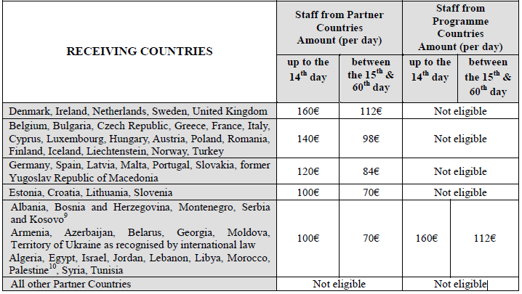

Financial support is granted to contribute to cover costs incurred during the mobility such as subsistence costs, accommodation, use of public transport and personal optional health insurance (see the Student/Staff Grant Agreement) for the individual participating in the mobility scheme. As reported in the E+ Programme Guide and here below, the amount provided varies depending, on the one hand on the destination and on the other, on the origin of the mobility whether it is from a Partner or a Programme country.

6 – Study fields
Final mobility programme shall be formally agreed both by the sending and receiving organisations.

7 - Required documents
Documents must be in PDF format only.
1- Declaration of Honour (example is to be downloaded; other template will be not accepted) – mandatory document.
2 - Passport copy – mandatory document.
3 - Curriculum Vitae (example is to be downloaded) – mandatory document.
4 - Language Certificate(s) (example is to be downloaded) – mandatory document.
5 - Recommendation Letter (Expert from the minute of University) – mandatory document.
7 - Motivation Letter – mandatory document.
8 - Proof of staff employment (Decree) – mandatory document.
9 – Grant agreement (example is to be downloaded) – mandatory document.
10 – Mobility agreement for training (example is to be downloaded) – mandatory document.
11 - Additional information (proof of socially disadvantaged situation, other certificates, portfolio, conferences’ diplomas) – facultative documents.

Please contact the Local Coordinator at the Home University in order for getting examples of the required documents or click on the link below.

IMPORTANT NOTE:

Complete application: You are requested to submit your application according to the rules of this Guideline. Each applicant, participating in the selection, declares to accept the rules and constraints defined by the Guidelines provided by EACEA. Please be aware that without providing all mandatory documents your application will be considered ineligible.

The mobility assignments must be based on partnership agreements between the members of the partnership. The Home and Host universities must agree the individual grand, learning agreements.
Also, to verify your eligibility on the SmaLog website.

8 – Documents upload procedure
For NUUE students:
- send all documents in the PDF format on the email nuuesmalog@gmail.com with file name “SMS_SmaLog_staff_participant last name”;
- bring all printed documents to the the Local Coordinator at the Home University

9 – Submission of the Application

Spring term
[month]
March

10 – Deadline

15^{s} of March 2019

11 - Evaluation procedure

Selection criteria for ACADEMIC/ADMINISTRATIVE STAFF
Curriculum Vitae | 0 points - insufficient; 1 point - sufficient; 2 points - good; 3 points - very good.
Recommendation letter(s) | The number of votes from the minute of University (Department)
Motivation letter | 0 points - insufficient; 1 point - sufficient; 2 points - good; 3 points - very good.
Language Certificate | 0 points - insufficient; 1 point - sufficient; 2 points - good; 3 points - very good.
Total Score

Applicants with fewer opportunities, from less advantaged socio-economic backgrounds, less experience rather than more experienced staff members will have priority.

12 – Selection results
Final lists of the candidates: Main List, Reserve List and Non-selected List will be drawn up as a result of the selection procedure and will be published on the SmaLog project website, section “Selection results”. The awarded candidate will receive an Award Letter from the Coordinating Office and will have 5 working days. After the acceptance of the grant, each grantee will receive an Invitation/Acceptance letter from the Host HEI.

Cross-cutting issues:
- Gender balance;
- Economically disadvantage groups with the corresponding supporting documents to be uploaded to the Application;
- Physically disabled participants with the corresponding supporting documents to be uploaded to the Application;
- Impact on the project outcomes (Doctorate, Post-doctorate, Academic/Administrative staff).

13 - Results notification timetable:

Publication of the call for applications | 25 of February 2019
Deadline for submission of applications and documentation | 15 of March 2019
Selection process | 20 of March 2019
Publication of results | 22 of March 2019
Sending of invitation letters to beneficiaries | April 2019
Start of mobilities | Depends from the EU University

For more info: http://smalog-2017.uniroma2.it/
For any doubt, see the following documents (to be downloaded):
Annex 1 Guidelines for the use of the Grant
Annex 2 Guidelines for the Special Mobility Strand

