Dear Applicant,

we are grateful for your interest to the
SmaLog project.
This Call for students will be opened
from the 1st of March of 2019 to 18^{s} of March of 2019.

Please note that you are submitting Application for the 2019-2020 academic year with the mobility starts from the September/October of 2019 till February/March of 2020.
1-Target Group
SmaLog project is opened for:
- students, who study in the master's program SmaLog.
Candidates must have obtained a Bachelor diploma and should be enrolled in SmaLog degree.
All the details on the Target groups are also available on the SmaLog website http://smalog-2017.uniroma2.it, section “Application Info”and on the website of UA and GE Universities.

2 - Eligibility Criteria
- academic merit;
- previous mobility experience;
- motivation;
- previous experience in the receiving country (i.e. return to country of origin);
- English language skills;
- willingness and appropriate attitude to studying and researching.
With other things being equal Preference will be assigned to students with fewer opportunities:
- economically disadvantage groups, which belong to the Low-income families in accordance with Ukrainian legislation:
- hildren from families of military servicemen by groups;
- children one of whose parents died as a result of a disease obtained in period of participation in the antiterrorist operation and etc.;
- orphans, children deprived of parental care, persons of their number;
- physically disabled participants:
- persons with disability I and II groups in accordance with Ukrainian legislation and etc.
- citizens belonging to preferential population groups in accordance with Ukrainian legislation.
3 - Types of mobility
Studying mobility with including traineeship period.

4 – Duration of mobility

European University | Period of travel
University of Rome Tor Vergata, Italy | September 2019 – March 2020
Sapienza University of Rome, Italy | September 2019 – February 2020
Politechnika Slaska, Poland | September 2019 – February 2020
Hochschule Wismar, University of applied Science: Technology, Business and Design, Germany | September 2019 –February 2020

5 – Financial conditions

According to the Guidelines for the Special Mobility Strand for grants awarded in 2017 under Call EAC/A03/2016:

- SUBSISTENCE COSTS: STUDENTS
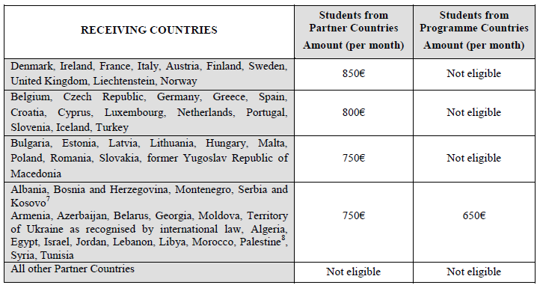
Germany 1 student:
Travel cost = 275 EURO
Poland 1 student:
Travel cost = 275 EURO
Italy 1 student:
Travel cost = 360 EURO

Financial support is granted to contribute to cover costs incurred during the mobility such as subsistence costs, accommodation, use of public transport and personal optional health insurance (see the Student/Staff Grant Agreement) for the individual participating in the mobility scheme. As reported in the E+ Programme Guide and here below, the amount provided varies depending, on the one hand on the destination and on the other, on the origin of the mobility whether it is from a Partner or a Programme country.

6 – Study fields
Please contact the Local Coordinator at the Home University in order to develop your plan of study/research/teaching/training.

7 - Required documents
Candidates must attach to their application all necessary supporting documents according to their academic level and type of mobility (all the documents must be in PDF format only).

1 - Declaration of Honour (example is to be downloaded) – mandatory document.
2 - Passport copy– mandatory document.
3 - Curriculum Vitae – mandatory document.
4 - Language Certificate(s) (example is to be downloaded) – mandatory document.
5 - Recommendation letter from Host Department – mandatory document.
6 - Bachelor Diploma – mandatory document.
7 - Master Transcript of Records (only if applicable) – facultative document.
8 - Grant_agreement (example is to be downloaded) – mandatory document.
9 – Learning_agreement for studies (example is to be downloaded) – mandatory document.
10 - Mobility Info (example is to be downloaded) – mandatory document.
11 – Additional information (proof of socially disadvantaged situation, other certificates, portfolio, conferences’ diplomas) – mandatory document.

Please contact the Local Coordinator at the Home University in order for getting examples of the required documents or click on the link below.

IMPORTANT NOTE:

Complete application: You are requested to submit your application according to the rules of this Guideline for every type of mobility (see section 7 “Required documents”). Please be aware that without providing all mandatory documents your application will be considered ineligible.
The mobility assignments must be based on partnership agreements between the members of the partnership. The Home and Host universities must agree the individual grand, learning agreements.
Also, to verify your eligibility on the SmaLog website.
When you receive an Award letter from the Coordination Office, you will have 5 days to confirm your acceptance to be part of the SmaLog project.

8 – Documents upload procedure
For NUUE students:
- send all documents in the PDF format on the email nuuesmalog@gmail.com with file name “SMS_SmaLog_student_student last name”;
- bring all printed documents to the the Local Coordinator at the Home University
9 – Submission of the Application

Spring term
[month]
March

10 – Deadline

18^{s} of March of 2019

11 - Evaluation procedure

The evaluation of each Application Form will be implemented according to the Selection criteria

Selection criteria for STUDENTS
1. Curriculum Vitae (Summary) | 0 points - insufficient; 1 point - sufficient; 2 points - good; 3 points - very good.
2. Language level | 0 points - insufficient; 1 point - sufficient; 2 points - good; 3 points - very good.
3. Academic records and awarded degrees | 0-4 points (according to the table below)
4.Interview | 0 points - insufficient; 1 point - sufficient; 2 points - good; 3 points - very good.
5. Recommendation letter from Host Department | 0 points - insufficient; 1 point – sufficient.
Total possible score – 14 points

Curriculum Vitae - an assessment of the reasons and motivational aspects of mobility participation identified in the summary.
Recommendation letter from Host Department – an assessment of the willingness and appropriate attitude to studying and researching, identified in the recommendation letter.
Interview - for avoiding the risk of insufficient language skills Host HEI has the authority to conduct an on-line interview of candidates by Skype or interview with the Head of the Department of Foreign Languages, representatives of International Center activities and Education, professors from Home Department.

Evaluation of Academic records according to the candidates Grade Point Average (GPA)
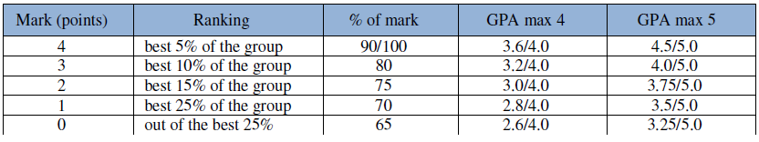

To calculate your GPA, please contact following link:
http://www.foreigncredits.com/Resources/GPA-Calculator/

As a result of this evaluation process by the Selection Board, a list of candidates will be drawn up.

Cross-cutting issues:
- Gender balance;
- Economically disadvantage groups with the corresponding supporting documents to be uploaded to the Application;
- Physically disabled participants with the corresponding supporting documents to be uploaded to the Application;
- Impact on the project outcomes (Doctorate, Post-doctorate, Academic/Administrative staff).

12 – Selection results

Final lists of the candidates: Main List, Reserve List and Non-selected List will be drawn up as a result of the selection procedure and will be published on the SmaLog project website, section “Selection results”. The awarded candidate will receive an Award Letter from the Coordinating Office and will have 5 working days. After the acceptance of the grant, each grantee will receive an Invitation/Acceptance letter from the Host HEI. The appeal can be lodged on written request to the Selection Committee not later than 2 days after announcement of selection results.

13 - Results notification timetable:

Publication of the call for applications | 25 of February 2019
Deadline for submission of applications and documentation | 18 of March 2019
Selection process | 25 of March 2019
Publication of results | 27 of March 2019
Sending of invitation letters to beneficiaries | April 2019
Visa application | April, May 2019
Start of mobilities | Depends from the EU University

For more info: http://smalog-2017.uniroma2.it/
For any doubt, see the following documents (to be downloaded):
Annex 1 Guidelines for the use of the Grant
Annex 2 Guidelines for the Special Mobility Strand
Annex 3 Guidelines on how to use the Learning Agreement for Studies

