Master in SMArt transport and LOGistics for cities SMALOG
585832-EPP-1-2017-1-IT-EPPKA2-CBHE-JP
www.smalog.uniroma2.it

Meeting of representatives of
WG1/Freight - Smart
WG2
WG3

University of Rome Tor Vergata
Sapienza University of Rome
April 2018, Rome, Italy

Aula Giunta – room 02-103
Civil Engineering Building, Engineering School
Via del Politecnico 1, 00133 Rome
Laboratorio dei Sistemi di Trasporto e Logistica
Engineering School
Via Edudossiana 18, 00100 Rome

Programme at a glance
Day
Monday, 9th April 2018 | Participant arrivals
Tuesday, 10th April 2018 | Meeting at the University of Rome Tor Vergata  meeting dinner
Wednesday, 11th April 2018 | Meeting at Sapienza University of Rome
Thursday, 12th April 2018 | Meeting at the University of Rome Tor Vergata
Friday, 13th April 2018 | Participant departures

Wednesday, 11th April 2018 (edited by UNIROMA1 – CTL)
Time | Topic | Speaker(s)
09:30 – 10:00 | Participant arrivals at Sapienza University of Rome
10:00 – 11:10 | Introduction to courses related to SmaLog delivered at the Sapienza University of Rome (part 1)  Syllabus of courses:  - Freight Transport and Logistics  - Traffic Engineering and ITS  - Transport Networks and vehicles | Dr. Andrea Campagna  Prof. Gaetano Fusco  Dr. Cristiana Piccioni
11:10 – 11:30 | break
11:30 – 13:00 | Introduction to the equipment related to SmaLog used at the Sapienza University of Rome:  - Safety Manager  - Sfinge  - Transcad  - Transmodeler  - Planimate | Dr. Roberto Carroccia  Dr. Eleonora Meta  Dr. Massimo Robibaro  Dr. Loris Mezzavilla
13:00 – 14:00 | Lunch time (free lunch)
14:00 – 15:30 | General information about the Master Degree in Transport Systems Engineering provided by Sapienza University  Quality system at Sapienza  In Introduction to courses related to SmaLog delivered at the Sapienza University of Rome (part 2):  Syllabus of courses  - Road Safety and Externality  - Transport Policies | Prof. Stefano Ricci  Prof. Luca Persia
15:30 – 16:00 | Introduction to the equipment related to SmaLog used at the Sapienza University of Rome:  - Softwares produced/used by Sistema Spin-off | Dr. Fiorani
16:00 – 16:30 | Exercises on main topics to be introduced in Partner Country institution courses:  - first draft of syllabi and equipment to use on course related to  - Freight  - Smart  - suggestions for other course: Passengers and Traffic | Roundtable - All

HOW TO REACH THE VENUE AT THE SAPIENZA UNIVERSITY
(CENTRE FOR TRANSPORT AND LOGISTICS – CTL)

Sapienza Engineering Faculty is close to the stop “Colosseo” of Metro Line B. If your hotel is close to a station of Metro Line A, take the Metro and get off to “Termini” station. There change to Line B direction “Laurentina”. The second stop is “Colosseo”. If your hotel is close to Metro Line B take the Metro and get off at stop “Colosseo”.
Arrived in the hall of “Colosseo” station don’t get off from the main exit in front of you but take the passage on your right where there is an escalator that goes over the station. You will exit on a terrace (a small square) in front of Colosseo (nice sight from there). Behind the Metro exit there is a pedestrian bridge, cross it and go straight on “Via della Polveriera”for about 200 m. You will arrive in front of the building of Engineering Faculty.

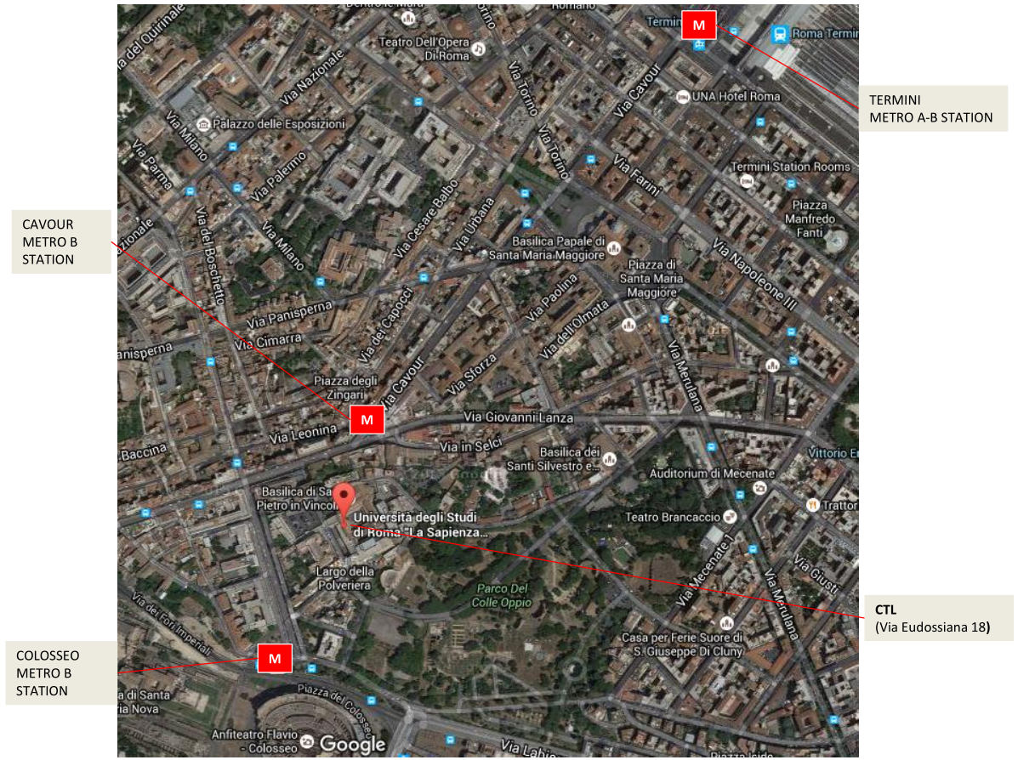

The meeting will be held at the “Laboratorio dei Sistemi di Trasporto e Logistica” in the fifth floor of the main building (painted in yellow).

